16 qubits simulator:

Time for each cycle:

0.754738 secs for cycle 0
0.153681 secs for cycle 1
0.229403 secs for cycle 2
0.327368 secs for cycle 3
0.36812 secs for cycle 4
0.323781 secs for cycle 5
0.061492 secs for cycle 6
0.837221 secs for cycle 7
0.217584 secs for cycle 8
0.194826 secs for cycle 9
0.299122 secs for cycle 10
0.253806 secs for cycle 11
0.023614 secs for cycle 12
0.517524 secs for cycle 13
0.21278 secs for cycle 14
0.596552 secs for cycle 15
0.19752 secs for cycle 16
0.584811 secs for cycle 17
0.092954 secs for cycle 18
0.023081 secs for cycle 19
0.07184 secs for cycle 20
0.169057 secs for cycle 21
0.111418 secs for cycle 22
0.145889 secs for cycle 23
0.308533 secs for cycle 24
0.310042 secs for cycle 25
0.292434 secs for cycle 26
0.740318 secs for cycle 27
0.137179 secs for cycle 28
0.167373 secs for cycle 29
0.236741 secs for cycle 30
0.167013 secs for cycle 31
0.171287 secs for cycle 32
0.265475 secs for cycle 33
0.615806 secs for cycle 34
0.186816 secs for cycle 35
0.558899 secs for cycle 36
0.204373 secs for cycle 37
0.274972 secs for cycle 38
0.202853 secs for cycle 39
0.143006 secs for cycle 40
0.408001 secs for cycle 41
0.15611 secs for cycle 42
0.568823 secs for cycle 43
0.324763 secs for cycle 44
0.529824 secs for cycle 45
0.109607 secs for cycle 46
0.164335 secs for cycle 47
0.33701 secs for cycle 48
0.236413 secs for cycle 49
0.186806 secs for cycle 50
0.021402 secs for cycle 51
0.843233 secs for cycle 52

5 cycles:
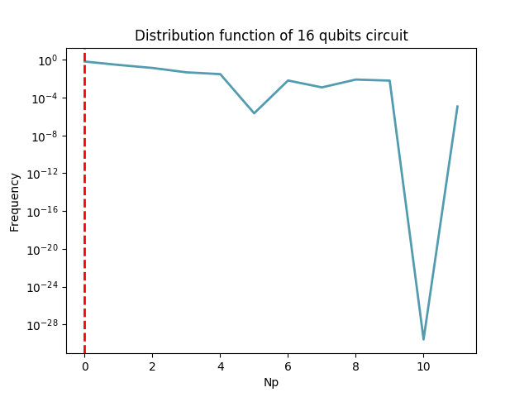

10 cycles:

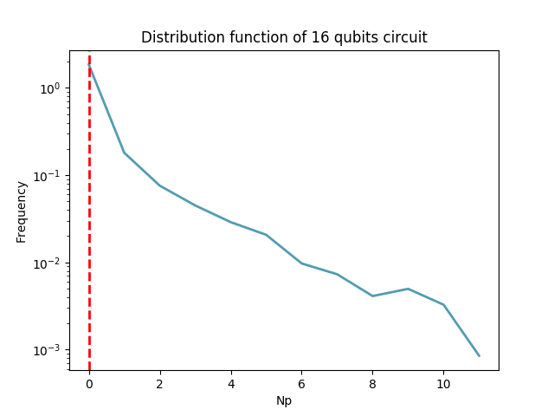

20 cycles:

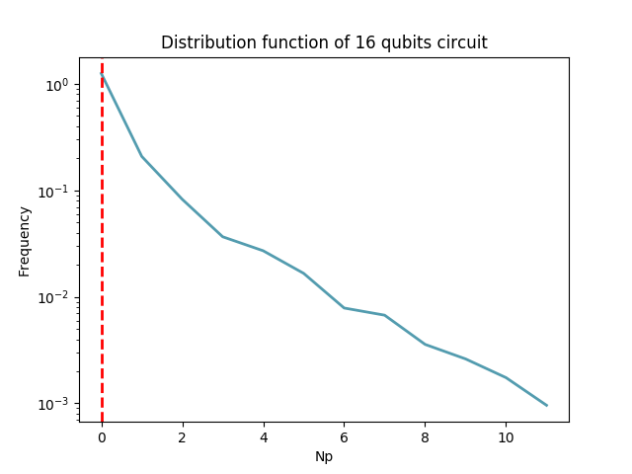

50 cycles:

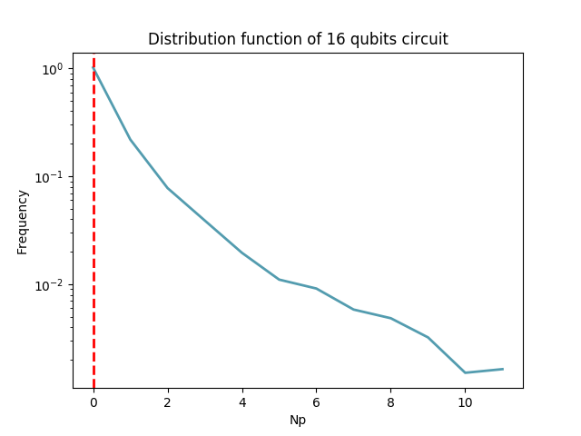

20 qubits simulator:

Time for each cycle:

14.7854 secs for cycle 0
2.18539 secs for cycle 1
5.98883 secs for cycle 2
13.0279 secs for cycle 3
5.14358 secs for cycle 4
12.2404 secs for cycle 5
6.09444 secs for cycle 6
11.1674 secs for cycle 7
1.17644 secs for cycle 8
3.31667 secs for cycle 9
8.84684 secs for cycle 10
7.61324 secs for cycle 11
7.2052 secs for cycle 12
5.53457 secs for cycle 13
7.5409 secs for cycle 14
2.88706 secs for cycle 15
7.28567 secs for cycle 16
19.4353 secs for cycle 17
1.57519 secs for cycle 18
0.381739 secs for cycle 19
5.42785 secs for cycle 20
7.26415 secs for cycle 21
6.26117 secs for cycle 22
4.01963 secs for cycle 23
2.63995 secs for cycle 24
0.377006 secs for cycle 25
1.60238 secs for cycle 26
4.6625 secs for cycle 27
6.33773 secs for cycle 28
8.66967 secs for cycle 29
3.63813 secs for cycle 30
7.55304 secs for cycle 31
2.32979 secs for cycle 32
5.26237 secs for cycle 33
8.03292 secs for cycle 34
11.5243 secs for cycle 35
7.20407 secs for cycle 36
12.411 secs for cycle 37
3.89385 secs for cycle 38
2.56939 secs for cycle 39
12.3237 secs for cycle 40
3.06205 secs for cycle 41
11.982 secs for cycle 42
7.43581 secs for cycle 43
9.91024 secs for cycle 44
3.82278 secs for cycle 45
1.8117 secs for cycle 46
2.66185 secs for cycle 47
6.34726 secs for cycle 48
5.66942 secs for cycle 49
13.1947 secs for cycle 50

5 cycles:

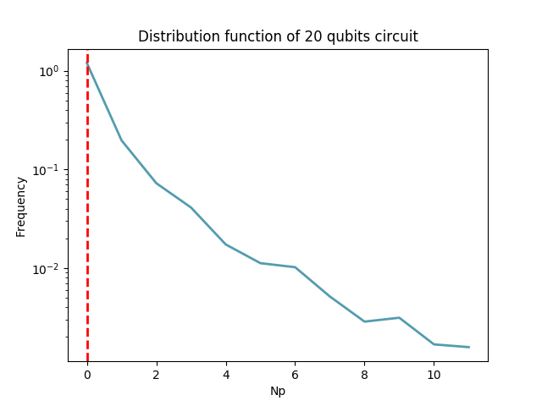

10 cycles:

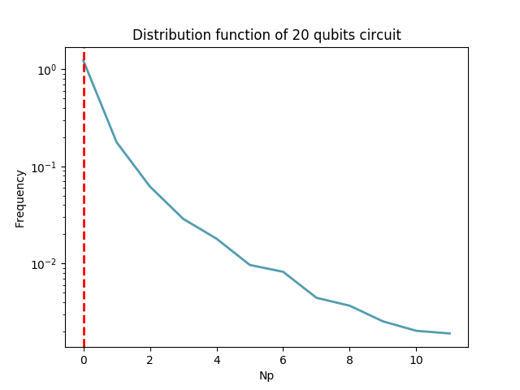

30 cycles:

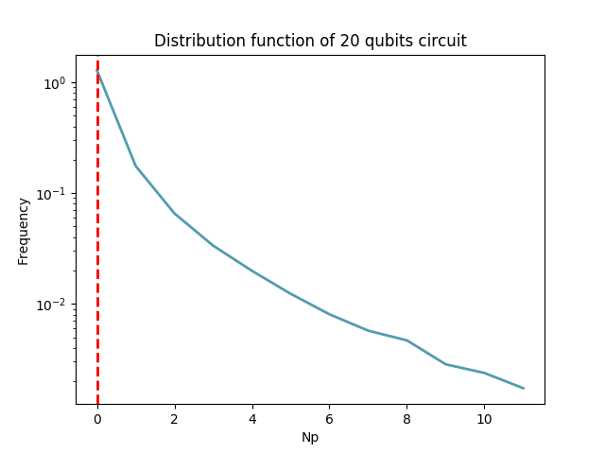

50 cycles:

